

WordClock 1–4
Word Clock System
Operator’s Manual

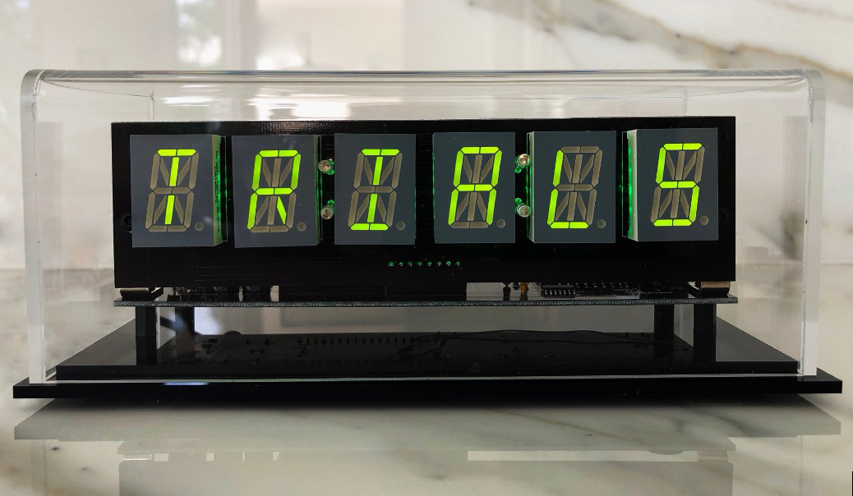 | 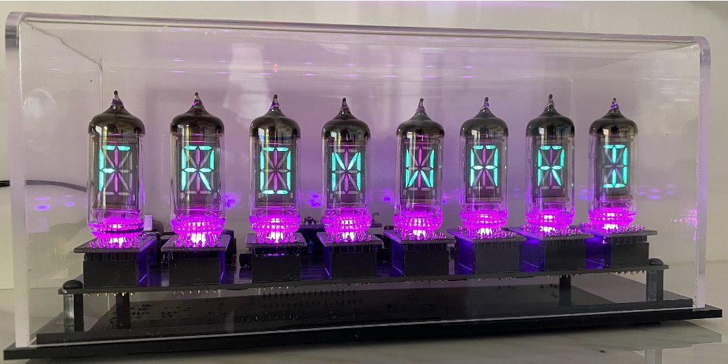
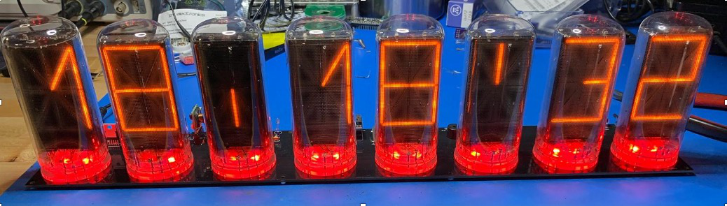 | 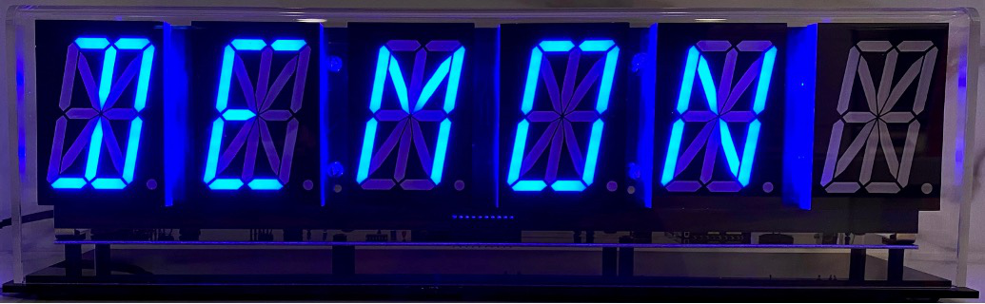
April 2026
This manual describes the installation, configuration, and day-to-day operation of the WordClock 1, 2, 3, and 4 family.
Revision/Update Information: | Initial release
Clock Firmware: | V9.0.13
Designed by Mitchell Feig — Angry Electrons
Distributed by StocksClocks LLC
Copyright © 2026 Mitchell Feig

Table of Contents

Quick Start QS-1
1. Overview 1-1
2. Models 2-1
3. Display 3-1
4. Buttons 4-1
5. Power-On Functions 5-1
6. AP Configuration Mode 6-1
7. Live Settings Web Interface 7-1
8. Period Overrides 8-1
9. Backlight (LED) Effects 9-1
10. Word and Time Change Effects 10-1
11. Info Display Cycle 11-1
12. Word Libraries 12-1
13. Sensors 13-1
14. Time Source 14-1
15. OTA Firmware Update 15-1
16. Factory Reset 16-1
17. Display Messages 17-1
18. Troubleshooting 18-1

Quick Start

Follow these steps to set up the WordClock for the first time. A full explanation of every option is in the numbered sections that follow.

1. Power on
Connect the clock to its 9–12V DC power adapter (1A or 2A minimum, depending on the model — see Section 2). Use a 5.5 × 2.1 mm center-positive barrel plug. On a brand-new clock, the display shows "AP" — this is Access Point configuration mode. (On a previously-used clock that already has WiFi credentials, skip to step 4 — to reconfigure WiFi, hold SW2 for 5 seconds during normal operation to enter AP mode.)

2. Connect to the clock's WiFi
From a phone or computer, open the WiFi settings and connect to the network named "WordClock-1-4" (or whatever model identifier matches the unit — for example, "WordClock-3-8" for an 8-digit VFD). No password is required.

3. Configure in a browser
Open a web browser and go to 192.168.4.1. The setup form loads. At minimum, navigate through the pages and:
- On the Setup page, select the home WiFi network from the SSID list and enter the password.
- Confirm the UTC offset for the local region (US Eastern is 5 hours Minus by default).
- On the Libraries page, confirm Library 1 is set (the default English library is required).
Press Save at the bottom of the form to store the selections, then press Start. The clock saves the settings, reboots, and begins normal operation.

4. Wait for time to appear
During boot, the display briefly scrolls "Wi-Fi" while connecting to the network, then "NTP" while fetching time from the internet. The display also scrolls each enabled library name and an "Index" or "No Idx" status for each. Time and rotating words appear within a few seconds of NTP sync.

5. Daily use
To do this | Do this
Wake the display from a quiet period | Click SW1 once
See the clock's IP address | Double-click SW1 — the address scrolls across the display
Cycle the expletive level (Off/Mild/Medium/Strong) | Click SW2 once
Adjust most settings live | Browse to http://<ip-address>/ from any device on the same WiFi
Send a custom scrolling message to the display | Use the Display Message field on the live web page
Install new firmware over WiFi | Hold SW1 for 10 seconds

6. Recommended next steps
- Visit the live web interface to explore backlight effects, colon patterns, word transitions, and other display options.
- Configure Period Overrides on the live page to dim or turn off the display during sleeping hours.
- If a BME280 weather sensor is installed, enable inside temperature and humidity on the Info Display page. To enable outside weather, register for a free Visual Crossing API key at visualcrossing.com and enter the key, postal code, and country on the Info Display page.

1. Overview

WordClock uses alphanumeric LED displays, VFD displays, or B7971 Nixie tubes to present the time, date, and rotating word libraries in a distinctive text-based format. Models are available with 6, 8, or 16 characters depending on display type.
The standard software includes an English word library, optional expletive files with selectable rudeness levels, announcements by month and day, and support for additional user-supplied libraries and languages. Words and phrases are stored on a removable SD card as plain-text files that can be edited with any text editor.
WordClock can synchronize time from a Wi-Fi NTP server or from an optional GPS receiver. Additional features include three independent display override periods, RGB backlight effects, inside and outside weather display, a live browser-based settings page, custom scrolling messages, and over-the-air firmware updates.
All settings are stored in non-volatile memory (NVS) and survive power cycles. Configuration is performed through a Wi-Fi access point setup page or a live web interface accessible from any device on the same network.
Note: Some included libraries — particularly the British slang collections and BadW libraries — contain language that some users consider offensive. Whilst that is somewhat the point, if young children or sensitive guests are present, the expletive level can be set to Off via SW2 or the live web page.

2. Models

WordClock is sold in several display variants. The hardware variant is set at the factory and identified by a code stored in the clock's flash memory; it cannot be changed by the user. The Access Point name and mDNS hostname both include the model identifier.
Model | Digits | Display Type | Notes
WordClock-1-6 | 6 | LED (alphanumeric) | 0.8" digits, single or dual LED ring backlight
WordClock-1-8 | 8 | LED (alphanumeric) | 0.8" digits
WordClock-1-16 | 16 | LED (alphanumeric) | 0.8" digits, dual I²C bus
WordClock-2-6 | 6 | LED (alphanumeric) | 2.3" digits
WordClock-2-8 | 8 | LED (alphanumeric) | 2.3" digits
WordClock-2-16 | 16 | LED (alphanumeric) | 2.3" digits, dual I²C bus
WordClock-3-6 | 6 | VFD (IV4 / IV17) | Vacuum-fluorescent tubes
WordClock-3-8 | 8 | VFD (IV4 / IV17) | Vacuum-fluorescent tubes
WordClock-3-16 | 16 | VFD (IV4 / IV17) | Vacuum-fluorescent tubes, dual I²C bus
WordClock-4-6 | 6 | Nixie (B7971) | Alphanumeric Nixie tubes, HV5530 driver
WordClock-4-8 | 8 | Nixie (B7971) | Alphanumeric Nixie tubes, HV5530 driver

Power supply: 9–12V DC, center positive, 5.5 × 2.1 mm barrel plug. The 6-digit LED models are typically supplied with a 1A adapter; 8- and 16-digit LED, VFD, and Nixie models are supplied with 2A. Use a quality regulated supply.
If the display shows "BAD" at power-on and never starts, the model code stored in flash is missing or invalid. Contact the distributor.

3. Display

Depending on the model, the clock has 6, 8, or 16 alphanumeric character positions. Each position is a 14- or 16-segment alphanumeric element capable of rendering ASCII letters, digits, and a number of special characters. RGB backlight LEDs sit behind each character and can run a variety of patterns (see Section 9).
A status indicator behind the leftmost character blinks briefly when Wi-Fi or NTP/GPS connectivity is lost. This blink can be suppressed via the live or setup form if desired.
On models that include colon segments between digit pairs, the colons can be configured to flash, scan, or stay solid (see Section 7, Colon Display).

4. Buttons

The clock has two buttons: SW1 (left) and SW2 (right). Their behavior differs between normal operation and power-on.

SW1 — During Normal Operation
Action | Function
Single click | Wake the display from a quiet period and start the temporary button-override timer (15 s, 1 min, or 5 min — see Section 8)
Double-click | Scroll the current IP address (or mDNS name) across the display when Wi-Fi is connected
Hold 10 seconds | Trigger an over-the-air (OTA) firmware update — see Section 15

SW2 — During Normal Operation
Action | Function
Single click | Cycle the expletive level: Off → Mild → Medium → Strong → Off. The level name briefly appears on the display.
Triple-click | Show the raw light-sensor reading for 30 seconds (calibration mode)
Hold 5 seconds | Reboot into Access Point configuration mode while preserving the current settings

Button Override
Pressing SW1 during a quiet period (a configured override) temporarily wakes the display and forces it to show the time only. The wake lasts for the configured Button Override duration: 15 seconds, 1 minute, or 5 minutes (default 15 seconds). After the timer expires, the display returns to its quiet-period state.

5. Power-On Functions

Special functions are available by holding buttons while applying power. These are read before the clock initializes its normal button handling. Apply power to the clock with the indicated buttons held; release once the clock acknowledges the action.
Buttons Held | Function
SW1 only | Rebuild word library indexes from the SD card. The display shows "Index" while running. See Section 12 for details on per-library rebuild and full rebuild options.
SW2 only | Burn-in mode. All segments stay on at full brightness until any button is pressed. Useful for exercising IV4 / IV17 VFD tubes on WordClock-3 models. Not available on Nixie variants.
SW1 + SW2 | Factory reset. Clears all stored settings (Wi-Fi credentials, display preferences, period overrides, weather, etc.) and reboots into Access Point mode. The hardware model code is preserved.

6. AP Configuration Mode

Entering AP Mode
- Hold SW2 for 5 seconds during normal operation, OR
- Apply power with SW2 held down (use the long-press method above for systems already configured), OR
- Power on a brand-new clock — it boots directly into AP mode
In AP mode the display shows "AP" continuously.

Connecting
1. Connect a phone or computer to the Wi-Fi network broadcast by the clock — by default "WordClock-1-4" (or "WordClock-3-8", etc., matching the model). The AP is open (no password).
2. Open a web browser and go to 192.168.4.1.
3. Step through the pages of the setup form. Press Save when finished, then Start to apply the settings and reboot.
The setup form is split across multiple pages — Setup (network and time), Libraries, Display, Overrides, and Info Display — to keep the interface manageable. Use the page buttons on the home page to navigate.

Setup Page — Network
Setting | Description
Access Point Name | Wi-Fi network name broadcast by the clock when in AP mode (default: WordClock-X-X matching the model)
SSID | Select the home Wi-Fi network from the scan list. SSIDs containing spaces may fail to connect.
SSID Override | Manually type an SSID if it does not appear in the scan list (for hidden networks). Overrides the dropdown selection.
Network Password | Wi-Fi password (max 25 characters; trailing spaces are not supported).
Live Form Password | Optional password for the live web interface. Leave blank for no password.
Primary NTP Server | Primary internet time server (default: time.cloudflare.com)
Alternate NTP Server | Backup time server, used if the primary becomes unreachable for more than 30 minutes (default: time.google.com)
Live Form | Enables or disables the live web interface during normal operation (default: Enabled)

Note on NTP servers: many home routers offer a built-in NTP server. Pointing all home devices to the router (e.g. 192.168.1.1) avoids excessive load on public servers and complies with the NTP Pool Project terms of service, which ask that SNTP clients query no more than once every 30 minutes.

Setup Page — Time and Time Zone
Setting | Options | Default
Time Source | Wi-Fi/NTP, GPS, Off | Wi-Fi/NTP
GPS Baud Rate | 4800, 9600, 19200, 38400, 57600 | 9600
Time Display | 12 Hour, 24 Hour, US English Verbose | 12 Hour
UTC Offset | HH:MM (supports half-hour and 45-minute regions) | 5:00
UTC Offset Direction | Minus, Plus | Minus

The Verbose time format spells the time in words — for example, "FIVE MINUTES AFTER 3" or "MIDNIGHT" — and works best on 8- and 16-digit displays.

Setup Page — Daylight Saving Time
Setting | Options | Default
DST Start Month | Jan–Dec | March
DST Start Week | 1–5 | 2
DST Start Day | Sun–Sat | Sunday
DST Start Hour | 0–23 | 2
DST Offset | 0 hr, 1 hr | 1 hr
DST Direction | Plus, Minus | Plus

Setup Page — Standard Time
Setting | Options | Default
ST Start Month | Jan–Dec | November
ST Start Week | 1–5 | 1
ST Start Day | Sun–Sat | Sunday
ST Start Hour | 0–23 | 2

Default DST and Standard Time settings are configured for US Eastern Time.

Libraries Page
Up to five word libraries can be active at once. Library 1 is required (it provides the system message file used for all status text and is the default content source). Libraries 2–5 are optional and only used when the corresponding Use Library percentage is non-zero. Each library is a folder on the SD card with files sharing the folder's base name.
Setting | Options | Default
Library 1 | Any folder on the SD card | English
Library 2 / 3 / 4 / 5 | Any folder on the SD card, or none | none
Use Library 2 / 3 / 4 / 5 | Off, 5%, 20% | Off
Time and Date Language | Always Library 1, Current Library | Always Library 1

"Always Library 1" forces the time and date to use the English (or Library 1) font and number labels even when a foreign-language library is currently displaying words. "Current Library" uses the active library's font for time and date.

Display Page
Setting | Options | Default
Display Brightness | 0–9 | 9
Clock Mode | Off, Every 15s, Every 30s, Every 60s, Always On | Every 30s
Colon Display | 9 patterns (off, on, scan, flash, etc.) | Pattern 4
Word Change Effect | Off, Slide Up, Slide Down, Slide Left, Slide Right, Energize, Random | Energize
Time Change Effect | Off, Slide Up, Slide Down, Slide Left, Slide Right, Random | Slide Right
Scroll All Words | Yes, No | No
Show Index Status at Start | On, Off | On
Show Announcements | Off, Every 60 s, Every 30 s | Every 30 s
Announcement Override | Off, On | Off
Backlight Effect | 14 effects + Cycle (see Section 9) | Random Multi-Color Wave
Backlight Brightness | 0–9 | 9
Expletive Default | Off, Mild, Medium, Strong | Off
Expletive Mix | 5%, 20%, 50% | 5%

Clock Mode controls how often the time replaces the rotating word display. "Always On" disables word rotation entirely. "Scroll All Words" forces every word — even those that fit the display — to scroll horizontally; otherwise short words are shown statically.

Overrides Page
See Section 8 for full details. Three independent quiet/dim periods can be defined here, plus the Button Override duration (15 s / 1 min / 5 min) used after a SW1 click.

Info Display Page
Setting | Options | Default
Info Display Start Second | 0–59 | 4
Date Display | MM/DD/YY, DD/MM/YY, YY/MM/DD, US English Verbose, Off | MM/DD/YY
Light Sensor | Disabled, Enabled | Disabled
Min Display Brightness | 0–9 | 3
Min Backlight Brightness | 0–9 | 3
Motion Sensor Timeout | Off, 15 s, 1 min, 5 min, 10 min, 15 min, 30 min, 1 hr | Off

See Section 11 for the date / weather / announcement display sequence and Section 13 for sensor details.

Info Display Page — Weather
Visible only when a Visual Crossing API key is configured or a BME280 inside sensor is detected.
Setting | Options | Default
Weather Key | Visual Crossing API key (text) | blank
Postal Code or Lat/Lon | Location for weather lookups | blank
Country Code | Two-character country code (e.g. US, GB, AU) | US
Inside Weather Display | Off, Temperature, Temperature + Humidity | Off
Outside Weather Display | Off, T, T+H, T+H+P, T+H+P+W | Off
Current Conditions | Off, On | Off
Scale | Imperial (°F, mph, inHg), Metric (°C, km/h, mb), Kelvin | Imperial
Inside Temperature Offset | −15 to +15 (1° increments) | 0
Labels | Off, Short, Long | Off
Display Duration | 5 seconds, 10 seconds | 5 seconds

OTA Update
The Firmware URL field on the Setup page configures where the clock fetches new firmware from when an OTA update is triggered. The default value (https://mitchsf.github.io/Firmware/) points to the manufacturer's firmware server. This field cannot be left blank; if cleared, it reverts to the default. See Section 15 for the update procedure.

7. Live Settings Web Interface

Once the clock is connected to a Wi-Fi network, the live settings page is reachable from any device on the same network. Most settings can be adjusted live without rebooting the clock — the change takes effect the moment the control is released.
Access: Browse to http://<clock-ip-address>/. To find the IP address, double-click SW1 — the address scrolls across the display.

Using a Name Instead of an IP Address (mDNS)
On many home networks the clock can be reached by name instead of by IP address. Browse to http://wordclock-1-4.local/ (or wordclock-3-8.local, wordclock-2-16.local, etc., matching the model) and the page should load. The hostname is derived from the Access Point Name set during configuration: lowercased, with any spaces or non-alphanumeric characters converted to hyphens. For example, an AP Name of "WordClock-1-4" becomes wordclock-1-4.local; "Kitchen Clock" becomes kitchen-clock.local. This makes it easy to give each clock in a multi-clock household a memorable address.
mDNS (also known as Bonjour or zero-configuration networking) does not work on every network. Some routers — particularly older models or routers with multicast filtering enabled — block the discovery messages mDNS depends on, in which case the .local address will not resolve. macOS, iOS, and Windows 10/11 generally work out of the box; some Android versions and Linux distributions require additional setup. If the .local address does not load, fall back to the IP address (double-click SW1 to display it).

Authentication
If a Live Form Password was set during AP configuration, the page prompts for it before any settings are shown. The username is left blank; enter the configured password. Clear the field in AP mode to disable authentication.

Display Page Controls
All changes take effect immediately. Use the Save to Memory button on each page to persist changes across power cycles; live changes alone are lost on reboot. The form is split across multiple pages with a home menu; the address bar shows which page is active.
- Display Brightness (0–9)
- Backlight Brightness (0–9)
- Backlight Effect (all 14 effects, see Section 9)
- Colon Display (9 patterns)
- Clock Mode (Off, Every 15 s, Every 30 s, Every 60 s, Always On)
- Word Change Effect (Off, four slide directions, Energize, Random)
- Time Change Effect (Off, four slide directions, Random)
- Show Announcements (Off, Every 60 s, Every 30 s)
- Announcement Override (force announcements during Always On)
- Expletive Default level and mix percentage

Overrides Page Controls
- Override Mode toggle (Enabled / Disabled) — temporarily suspends all three override periods without deleting them. This setting is not saved; on reboot it returns to Enabled.
- All settings for Override 1, 2, and 3 — start time, end time, days, brightness, backlight effect and brightness, clock mode, colon display
- Button Override Duration (15 s, 1 min, 5 min)

Info Display Page Controls
- Info Display Start Second (0–59)
- Date Display format
- Motion Sensor Timeout
- Light Sensor enable, Min Display Brightness, Min Backlight Brightness
- Inside / Outside weather display modes, scale, temperature offset, labels, duration

Custom Scrolling Message
The home page of the live web interface includes a Display Message text field (up to 64 characters). Type a message and press Send. The message scrolls across the display once at the next opportunity, then the clock returns to its normal display sequence. This is useful for greetings, reminders, or quick announcements visible to anyone in the room.

Override Mode Toggle
Override Mode is a "master switch" for all three quiet-period schedules. When set to Disabled, the clock ignores every period and runs at standard brightness and effects regardless of the time of day. This is helpful when guests are visiting and the configured night-time dim is not wanted. The toggle lives on the Overrides page and is always visible there. The setting is intentionally not saved to memory — on reboot, Override Mode returns to Enabled so the configured schedules resume automatically.

8. Period Overrides

Three independent override periods can each schedule a different display configuration for specific times of day and days of the week. The most common use is to dim or turn the display off during sleeping hours.
Setting | Description
Start Time | When the period begins, in 24-hour HHMM format (e.g. 2300 = 11:00 PM)
End Time | When the period ends, in 24-hour HHMM format (e.g. 0700 = 7:00 AM)
Days | All days, Weekdays only, or Weekends only
Display Brightness | 0–9 (0 = display off; on Nixie models the high-voltage supply is also disabled)
Backlight Effect | Any backlight effect, including Off
Backlight Brightness | 0–9
Clock Mode | Off, Every 15 s, Every 30 s, Every 60 s, Always On
Colon Display | Any colon pattern, including Off

Setting Start Time equal to End Time disables the period. Periods may wrap across midnight (e.g. 2200 to 0700).
Priority: when two or more periods overlap, the lowest-numbered period wins (Period 1 > Period 2 > Period 3).
Override Mode (live web page) suspends all three periods without erasing them. When Override Mode is Disabled the clock runs at standard settings regardless of the time of day.
Button Override: a single click of SW1 during an active period temporarily wakes the display and forces Clock Mode 4 (always on, time only) for the configured Button Override duration (15 seconds, 1 minute, or 5 minutes). When the duration expires, the period's settings resume.

9. Backlight (LED) Effects

A row of RGB LEDs sits behind the alphanumeric characters and provides a colored backlight. The number of LEDs depends on the model — some 6-digit clocks use 6 LEDs, others use 12 or 24; 8-digit clocks use 8, 16, or 32; the largest 16-digit clocks use up to 64. Effects scale automatically to the LED count.
# | Effect | Description
0 | Off | All LEDs dark
1 | USA Wave | Red, white, and blue cycling with sine-wave brightness modulation
2 | Israel Wave | Blue and white alternating wave
3 | Random Big Color Wave | Single random color (8-bit RGB) with sine-wave fade
4 | Random Every Color Wave | Single random full-spectrum color with sine-wave fade
5 | Random Multi-Color Wave | Different random color per LED with sine-wave fade (default)
6 | Twinkle | Random colors per LED, fading independently
7 | Red Fade | Red sine-wave fade
8 | Green Fade | Green sine-wave fade
9 | Blue Fade | Blue sine-wave fade
10 | Solid Red | Steady red, no animation
11 | Solid Green | Steady green, no animation
12 | Solid Blue | Steady blue, no animation
13 | Cycle 1–9 | Rotates through effects 1–9, switching every 10 seconds at the top of each minute

Backlight Brightness (0–9) is gamma-corrected so that small numbers correspond to dim, evenly-spaced steps and large numbers ramp up to maximum. Setting Brightness to 0 turns the LEDs off without changing the selected Effect.
Status indication: when the time source (Wi-Fi/NTP or GPS) is lost, the leftmost LED briefly turns off and back on roughly every 1.5 seconds. This indicator can be temporarily blanked by the configured period override.

10. Word and Time Change Effects

Two independent transition effects animate how new content appears on the display.

Word Change Effect
Applied each time a new word from the active library replaces the previous word.
Effect | Description
Off | Instant replacement, no animation
Slide Up | New word slides in from below
Slide Down | New word slides in from above
Slide Left | New word slides in from the right
Slide Right | New word slides in from the left
Energize | Per-segment "energize" sweep — looks particularly good on VFD models
Random | Picks a random slide direction each time

Time Change Effect
Applied each time the displayed time updates (controlled by Clock Mode — see Section 7).
Effect | Description
Off | Instant replacement, no animation
Slide Up | New time slides in from below
Slide Down | New time slides in from above
Slide Left | New time slides in from the right
Slide Right | New time slides in from the left (default)
Random | Picks a random slide direction each time

11. Info Display Cycle

The clock periodically interrupts the rotating word display to show date, weather, and announcement information. Most info shown depends on the configured Date Display, weather, and announcement settings.

Information Shown (if enabled)
Date: Displayed as MM/DD/YY, DD/MM/YY, YY/MM/DD, or US English Verbose ("April 29, 2026"). Set Date Display to Off to skip the date.
Inside Weather: Read from a BME280 sensor on the I²C bus (auto-detected at addresses 0x76 and 0x77). Temperature alone, or temperature with humidity. The Inside Temperature Offset can be used to correct sensor calibration.
Outside Weather: Fetched from Visual Crossing (https://visualcrossing.com — a free API key is required). Up to five elements can be displayed: temperature, humidity, pressure, wind, and conditions. Wind shows as both speed and 16-point compass direction (N, NNE, NE, ENE, E, ...).
Current Conditions: A short text description (e.g. "PARTLY CLOUDY") appended to the outside weather display when enabled.
Announcements: Day-of-month or month-and-day messages from the Library 1 announcements file (see Section 12). Shown every 30 or 60 seconds when enabled, or on demand at midnight.

Display Timing
Info Display Start Second (0–59) controls when in each minute the date / weather / announcement cycle begins. Display Duration (5 s or 10 s) controls how long each weather element is held on the display before transitioning to the next.
Labels can be turned Off, Short ("T-72.4F"), or Long ("TEMPERATURE 72.4F") to fit different display widths.

Weather Update Schedule
When outside weather is enabled, the clock fetches a fresh forecast every 15 minutes. If the fetch fails, it retries after 5 minutes. Data older than 1 hour is treated as stale and the previous values are cleared until a successful fetch.

12. Word Libraries

Words, fonts, system messages, expletives, and announcements are all stored on a removable SD card. Each library is a folder at the root of the card, and the files inside share the same base name as the folder. Up to five libraries can be active at once; the SD card may contain up to 25 library folders to choose from.

Folder Structure
Each library folder contains a font file and a word file at minimum. Optional files add expletives, announcements, system messages, and a search index. For example, an English library would contain:
- /English/English.fnt — character bitmaps (required)
- /English/English.wds — word and phrase list (required)
- /English/English.idx — search index (optional, auto-generated)
- /English/English.msg — system messages (required for Library 1 only)
- /English/English.xpl — expletive list with rudeness levels (optional)
- /English/English.ano — month/day announcements (optional, Library 1 only)
Library names may be up to 8 characters long and cannot contain spaces. Folders beginning with a dot ( . ) and the special folder EXTRAS are skipped.

Fonts (.fnt)
Plain-text files. Each line begins with 16 zeros and ones describing the segment states for one character, in the order: u t s r p n m k h g f e d c b a. ASCII characters from 32 to 255 may be defined within the limits of the display hardware. Comments after the 16-character segment definition are ignored.
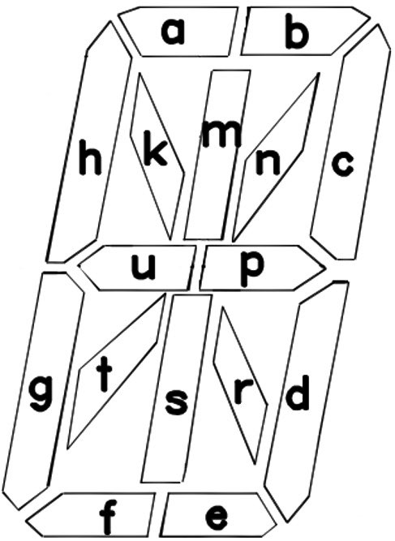
The diagram above shows the segment letter map for one alphanumeric character — each of the sixteen segments corresponds to one bit in the font definition.

Words (.wds)
Plain-text. Each line is a single word or phrase up to 64 characters. Two short words can share one line by separating them with a pipe ( | ). The first line is treated as a header comment and is never displayed.

Messages (.msg)
Required only in Library 1. The default message file supplies the strings shown for system events (Wi-Fi, GPS, NTP, AP, expletive level names, weather, etc.). Required entries must appear in the expected order — see the supplied default file for the canonical layout.

Expletives (.xpl)
Optional. Each line contains a word or phrase, a pipe ( | ), and a level from 1 to 3. Higher levels include all lower levels (level 3 = Strong includes Mild and Medium content). Up to 125 entries per file. The first line is treated as a header comment.

Announcements (.ano)
Optional, Library 1 only. Each line begins with day and month in DD-MM format followed by the announcement text (up to display-width characters). A month value of 00 fires the announcement on that day of every month.

Indexes (.idx)
A binary-style index that lets short and long entries be selected with equal probability. Whenever a word file is edited, its index must be rebuilt. There are three ways to do this:
- To rebuild every library, hold SW1 while applying power. Release once "Index" appears. The clock indexes each library in turn before continuing the boot sequence.
- To rebuild a single library, watch the boot screen — each enabled library name briefly scrolls. Press and hold SW1 while the desired library name is shown, and only that library will be reindexed.
- Indexes are automatically generated on first use if missing — the clock displays "No Idx" briefly during the boot sequence to indicate which libraries lack an index.
Library 1 is required at all times. Removing it (or replacing it without a message file) prevents the clock from booting normally.

13. Sensors

Light Sensor
When enabled (Light Sensor = Enabled), the clock continuously samples ambient light and dims both the display and backlight in dim rooms. The Min Display Brightness and Min Backlight Brightness settings prevent the display from going completely dark. With the sensor disabled, the configured brightness values apply at all times.
Calibration: triple-click SW2 to enter calibration mode. The raw sensor reading (a small number from 0 to 15) is shown on the display for 30 seconds. Use this to confirm the sensor is responding and to set the Min Brightness values appropriately for the room.

Motion Sensor (PIR)
When the optional PIR motion sensor is installed and a non-Off timeout is configured, the display blanks after the timeout has elapsed with no detected motion. When motion is detected, the display fades back in to the configured brightness; when motion stops and the timeout expires, the display fades out again. Available timeouts: 15 s, 1 min, 5 min, 10 min, 15 min, 30 min, and 1 hour.
A 30-second warm-up period applies after every power-on so that the sensor has time to stabilize.

BME280 Weather Sensor
If a four-pin BME280 module is connected to the I²C bus, inside temperature, humidity, and barometric pressure are auto-detected at startup (addresses 0x76 and 0x77). When detected, the Inside Weather Display options become active in the setup and live forms. The Inside Temperature Offset (−15 to +15 in 1° steps) can be used to compensate for sensor self-heating.

14. Time Source

Wi-Fi / NTP
The default time source. The clock fetches time from a Network Time Protocol (NTP) server roughly every four hours, with random jitter to avoid synchronized polling. If the primary server (default time.cloudflare.com) is unreachable for more than 30 minutes, the alternate server (default time.google.com) takes over automatically. The clock falls back to the primary as soon as it becomes responsive.
NTP requires Internet access. Without an Internet connection the clock continues to run on the ESP32's internal oscillator but slowly drifts; use a router-hosted NTP server for offline networks.

GPS
An optional GPS receiver can be connected to the hardware serial port (RX on GPIO 12, GND, and 3.3V or 5V depending on the receiver). When Time Source is set to GPS, the clock derives time directly from satellite fixes and does not require Wi-Fi. The GPS Baud Rate setting must match the receiver — most modern receivers use 9600 (the default).
A clear sky view is needed for the initial fix. The display shows "GPS" while waiting for a valid time message.

Off
Disables time synchronization entirely. The clock runs purely from the internal oscillator, which drifts on the order of seconds per day. Useful for table-top demonstrations or when no time source is available.

15. OTA Firmware Update

The clock can update its own firmware over Wi-Fi. To trigger an update, hold SW1 for 10 seconds during normal operation. The clock checks the configured firmware server, downloads any newer version, and reboots automatically.

Display Feedback
OTA status messages appear on the full display as scrolling text or short codes. The progression is:
Display | Meaning
UPDATE | Update started. The clock is connecting to Wi-Fi and the firmware server.
LATEST | The installed firmware already matches the version on the server. The clock displays the version briefly, then returns to normal operation.
(progress) | A new firmware binary is being downloaded and written to flash.
OK | Update succeeded. The clock reboots automatically after a short delay.

Error Codes
If the update cannot complete, an error code is shown briefly and the clock returns to normal operation:
Code | Meaning
ERROR1 | No Wi-Fi connection or no firmware URL configured.
ERROR2 | The VERSION file on the firmware server could not be retrieved.
ERROR3 | The VERSION file is malformed (missing or invalid version string).
ERROR4 | The firmware binary failed to download or could not be written to flash.

Version Behavior
Major version change (e.g. 8.x.x to 9.x.x): all settings are reset to factory defaults after the update. This guarantees clean migration when the configuration format changes between major releases.
Minor or patch change (e.g. 9.0.11 to 9.0.12): all settings are preserved.

Requirements
A working Wi-Fi connection and a valid Firmware URL are required. The default URL points to the manufacturer's firmware server (https://mitchsf.github.io/Firmware/) and should be left at the default unless directed otherwise.

Manual Reflash
In rare situations — for example, if the clock will not boot far enough to perform an OTA update — firmware can also be loaded over USB using Espressif's Flash Download Tool. Detailed manual-reflash instructions are available from the distributor on request.

16. Factory Reset

To reset all settings to factory defaults:
1. Remove power from the clock.
2. Press and hold both SW1 and SW2.
3. Apply power while continuing to hold both buttons.
4. Continue holding until the display clears (about 5 seconds).
5. Release both buttons. The clock restarts in AP configuration mode.
All Wi-Fi credentials, display preferences, period overrides, weather settings, and library selections are erased. The hardware model code (which identifies the unit as a WordClock-1-4, WordClock-3-8, etc.) is preserved.
A factory reset is also performed automatically when an OTA update changes the major version number (see Section 15).

17. Display Messages

In addition to time, words, weather, and announcements, the clock displays a number of short status messages. The most common are listed here.
Display | Meaning | Operator Action
AP | Access Point configuration mode — waiting for setup. | Connect to the WordClock-X-X Wi-Fi and configure at 192.168.4.1.
Wi-Fi | Connecting to a Wi-Fi network. | Wait for connection. If it does not complete, verify SSID and password in AP mode.
NTP | Connecting to the NTP time server. | Wait for time sync. Check internet connectivity if it stalls.
GPS | Waiting for a GPS fix. | Ensure the receiver has a clear view of the sky.
WX | Fetching weather data. | Wait for the fetch to complete or verify API key and location.
Index | A search index exists for the displayed library (boot only). | No action required.
No Idx | No search index exists for the displayed library. | Rebuild the index if the library has been edited (see Section 12).
SDcard | The SD card cannot be mounted or is not present. | Reseat or replace the card. Format as FAT32 if needed.
Font X | The font file for Library X is missing. | Install the missing .fnt file in the affected library folder.
Word X | The word file for Library X is missing. | Install the missing .wds file in the affected library folder.
Mesg 1 | The message file for Library 1 is missing. | Add the required .msg file to Library 1.
BAD | Software licensing or hardware-code violation. | Contact the distributor.
UPDATE / OK / ERROR1–4 | OTA firmware update progress (see Section 15). | See the OTA section for the appropriate response.

Status indicator: the leftmost backlight LED briefly turns off and back on every 1.5 seconds whenever the time source is unavailable. This blink can be hidden during a configured override period if desired.

18. Troubleshooting

Symptom | Possible Cause | Solution
Display is blank after power on | Waiting for Wi-Fi association or NTP time sync | The display shows "Wi-Fi" while connecting and "NTP" while syncing. If neither completes within ~2 minutes the software watchdog reboots the clock and tries again.
Display shows steady "AP" | Clock is in AP configuration mode | Connect to the WordClock-X-X Wi-Fi and configure at 192.168.4.1.
Display shows steady "BAD" and never starts | Missing or invalid hardware model code | Contact the distributor; the unit needs re-provisioning.
Display shows "SDcard" | SD card not present, unreadable, or wrong format | Reseat the card or reformat as FAT32 with at least Library 1 installed.
Display is dim during the day | Light sensor active and ambient light is low | Triple-click SW2 to view the raw sensor value. Increase Min Display Brightness or disable the sensor.
Status LED blinks briefly off | Wi-Fi or NTP/GPS connection lost | The clock is reconnecting automatically. If the blink persists, check the router or re-enter AP mode.
Wi-Fi will not connect at boot | Wrong credentials or out of range | Hold SW2 for 5 seconds to enter AP mode and reconfigure Wi-Fi.
Time is wrong by a whole hour | Incorrect DST or Standard Time configuration | Check DST/ST start month, week, day, and offset in AP setup.
Time is briefly wrong, then corrects | Primary NTP server slow; alternate took over | Normal behavior. The clock falls back to the alternate NTP server after the primary is stale for 30 minutes.
Words look funny / characters missing | Font file for the active library is corrupt | Reinstall the .fnt file from the distributor's library package.
Library does not appear in setup form | Library folder name has spaces or is too long | Rename to ≤ 8 characters with no spaces and reseat the SD card.
New words from edited library are not appearing | Word file edited but index not rebuilt | Hold SW1 at power-on (or while the library name scrolls) to rebuild the index.
Weather "WX" appears repeatedly without succeeding | Wrong API key, postal code, or country code | Re-check the Visual Crossing key and the location format in AP setup.
Inside weather options not visible in form | BME280 sensor not detected on the I²C bus | Reseat the sensor; verify wiring; confirm address 0x76 or 0x77.
OTA shows ERROR1 | No Wi-Fi or missing Firmware URL | Reconnect to Wi-Fi and verify the Firmware URL on the Setup page.
OTA shows ERROR2 / ERROR3 | Firmware server unreachable or version file invalid | Check internet access; restore the Firmware URL to its default if it has been changed.
OTA shows ERROR4 | Download or flash write failed | Power-cycle and try again. If it persists, perform a manual reflash via USB.
Live web page will not load | Live Form disabled or wrong password | Verify Live Form is Enabled in AP setup, and the Live Form Password matches.
Backlight LEDs not lighting | Brightness set to 0, or LEDs disabled by override | Check Backlight Brightness; verify no period override is forcing them off.
Display dims unexpectedly at night | Period override active | Press SW1 to wake the display temporarily, or adjust the override on the Overrides page.

Copyright and Disclaimer

WordClock firmware and documentation © 2026 Mitchell Feig d/b/a Angry Electrons. All rights reserved. Exclusively distributed by StocksClocks LLC.
THIS PRODUCT AND ITS FIRMWARE ARE PROVIDED "AS IS", WITHOUT WARRANTY OF ANY KIND, EXPRESS OR IMPLIED, INCLUDING BUT NOT LIMITED TO THE WARRANTIES OF MERCHANTABILITY, FITNESS FOR A PARTICULAR PURPOSE, AND NONINFRINGEMENT. IN NO EVENT SHALL THE AUTHOR OR COPYRIGHT HOLDER BE LIABLE FOR ANY CLAIM, DAMAGES, OR OTHER LIABILITY, WHETHER IN AN ACTION OF CONTRACT, TORT, OR OTHERWISE, ARISING FROM, OUT OF, OR IN CONNECTION WITH THE PRODUCT, ITS FIRMWARE, ITS DOCUMENTATION, OR THE USE OR OTHER DEALINGS WITH ANY OF THE FOREGOING.
Nixie variants of this clock contain a small amount of mercury and neon gas under low pressure and operate from an internal high-voltage supply (~170 V). Operate the clock at the supplied voltage only; do not open or service the high-voltage circuitry.
A good-faith effort has been made to remove offensive content based on race, religion, or sexual orientation from the included libraries. Please report any remaining offensive entries, together with the library name and the specific word or phrase, to the distributor.
WordClock — Designed by Mitchell Feig

